**Practical 6: Using JFLAP, create SLR(1) parse table for a given grammar. Simulate parsing and output the parse tree in proper format.**

**Aim:** Using JFLAP create SLR(1) parse table for a given grammar. Simulate parsing and output the parse tree proper format.

**Implementation: -**

**Step 1: -** Choose the grammar from JFLAP and insert grammar you want to create SLR(1) parsing table.

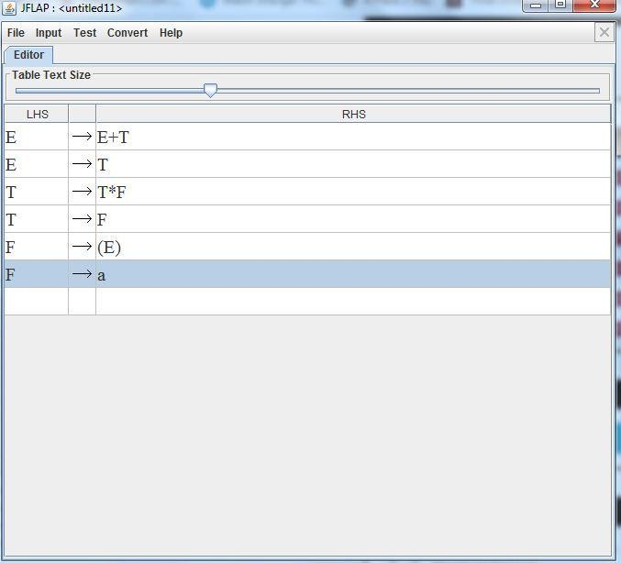

**Step 2: -** Select the Input from Menu and select Build SLR (1) parsing table from it.

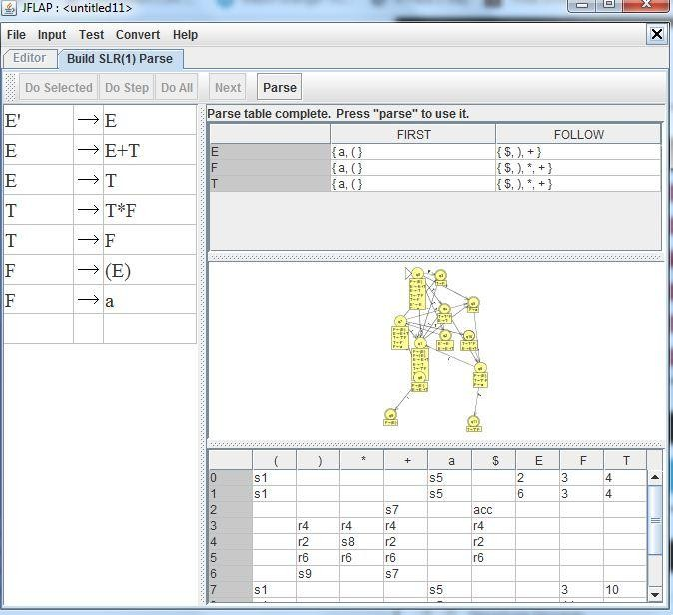

**Step 3: -** Now select parse to use that table to create parse tree from it.

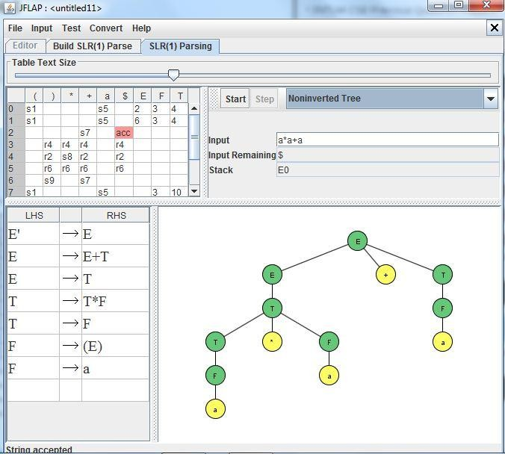

**Result :-** We created SLR(1) parse table for a given grammar and Simulated parsing and output the parse tree proper format.